ThinkItThru! — Project Design

By Jensen Schmidt, Levi Wright, and Zachary Travis

# Table of Contents

Requirements List 1

(Onboarding) Sign-in Form 2

(Onboarding) Registration Form: 2

(General) Modal 3

(General) Dialog Box 3

(General) New Task Modal 3

(Dashboard) Navbar 5

(Dashboard) Tasks 7

(Dashboard) Game 12

Design Description 15

Overview 15

Features and Layout 15

Server Structure 16

Functionality 18

Appendix 21

Figure 1: Block Diagram 21

Figure 2: Component Diagram 21

Figure 3: UI Storyboard 22

Figure 4: Message Documentation 24

Figure 5: Entity Relationship Diagram 25

# Requirements List

## (Onboarding) Sign-in Form

* 1. The sign-in form will be a single message, with the following:
     1. A header text, “Sign-in using Socials:”
     2. A clickable button to sign in using a Google account, labeled, “Sign-in with Google”.
        1. On-click, the Google account authentication will occur.
           1. If the Google account has any prior information in the database, the user will be taken to the **dashboard.**
           2. If the Google account does not have prior information in the database, the user will be taken to the **registration form**, modified to not require an email address or password.
     3. A clickable button to sign in using a Google account, labeled, “Sign-in with Facebook”.
        1. On-click, the Facebook account authentication will occur.
           1. If the Facebook account has any prior information in the database, the user will be taken to the **dashboard.**
           2. If the Facebook account does not have prior information in the database, the user will be taken to the **registration form**, modified to not require an email address or password.
     4. A clickable button to sign in using a Google account, labeled, “Sign-in with X”.
        1. On-click, the X account authentication will occur.
           1. If the X account has any prior information in the database, the user will be taken to the **dashboard.**
           2. If the X account does not have prior information in the database, the user will be taken to the **registration form**, modified to not require an email address or password.
  2. The sign-in form should adhere to best practices for ease-of-access from the user.
     1. Every label should be navigable by keyboard.
     2. Every label should select their input fields when clicked by the user.
     3. Every label should use aria text.
     4. Every input field should be navigable by keyboard.
     5. Every input field—except the password field—should have default placeholder text.
     6. Every input field should use aria text.

## (Onboarding) Registration Form:

* 1. The sign-up form will contain one component including the following:
     1. A text label, “First Name”.
     2. An input text field connected to the “First Name” label.
        1. The input text field will have a placeholder value of “Jane”.
        2. The input box will not accept numbers and special characters, only letters.
           1. With invalid input, a message under the field will state that this field can only accept letters.
        3. A “*” symbol will be marked next to the field to indicate a required component.
     3. A text label, “Last Name”.
     4. An input text field connected to the “Last Name” label.
        1. The input text field will have a placeholder value of “Doe”.
        2. The input box will not accept numbers and special characters, only letters.
           1. With invalid input, a message under the field will state that this field can only accept letters.
        3. A “*” symbol will be marked next to the field to indicate a required component.
     5. A text label, “Major”.
        1. A drop-down menu field with the available majors with the application.
        2. A “*” symbol will be marked next to the field to indicate a required component.
     6. A clickable button labeled “Create Profile”.
        1. When clicked, if any required fields are empty, a dialog box will display, stating, “Please enter all required material.”
        2. When clicked, if there are no status messages and all the fields are filled out, the information is submitted to the back-end.
           1. The user is then logged into their account and the application navigates to the dashboard.

## (General) Modal

* 1. All **modals** will have an “X” button that will close the **modal.**

## (General) Dialog Box

* 1. The dialog box will have a clickable button labeled, “Ok”, that closes the dialog box when clicked.
  2. The dialog box will display a message depending on what has triggered it.

## (General) New Task Modal

* 1. The **modal** should contain a clickable close button indicated with an “X”.
  2. The **modal** should contain a title label, “New Task”.
  3. This **modal** will have text labels for the following:
     1. “Name of the Task:”
        1. By this label, a text input field should be set with a placeholder value of “Task Name”.
        2. The input field should only accept a minimum of 3 characters and a maximum of 80 characters.
        3. The input field should only accept letters, numbers, and specific special characters (:, ”, ’, (, ), -, &, /, !, and .)
        4. If the input field contains invalid characters, a message should be displayed below the field stating so, along with the only valid characters allowed.
     2. “What is the date the task should be done by? Or is it recurring on a daily/weekly basis? ”
        1. By this label, a text input field should be set with a placeholder value containing the current date in the correct format (Month/Day/Year).
           1. The input field should only accept dates with the correct format.
           2. The input field should only accept dates past the current date.
           3. The input field should only accept letters, numbers, and one special character (/).
           4. If the input field contains invalid characters or an invalid date format, a message should be displayed below the field stating so, along with the input restrictions and format.
           5. If the input field contains an invalid date, a message should be displayed below the field stating, “Invalid Date”.
        2. Also by this label and field, a clickable option will be labelled as “Daily Recurring”.
        3. Also by this label and field, a clickable option will be labelled as “Weekly Recurring”.
     3. “The Task’s Level of Difficulty, On a Scale from 1 (Easy) to 10 (Difficult):”.
        1. By this label, there should be an input field that should only accept integers between 1-10.
        2. If the input field contains invalid input, a message should display beneath the field stating so.
     4. “What is the estimated number of hours it will take to complete this task?”
        1. By this label, there should be an input field that should only accept positive integers and should have a maximum of
     5. “What is the minimum amount of time, in minutes, you can work on this task in a day?”
        1. By this label, there should be an input field that only accepts positive integers and a number less than the biggest number of minutes the user has allotted for any day.
        2. If the input field contains invalid input, a message should display beneath the field stating so.
     6. “What is the maximum amount of time, in minutes, you can work on this task in a day?”
        1. By this label, there should be an input field that only accepts positive integers and a number less than the biggest number of minutes the user has allotted for any day.
     7. “Is this a low-priority task, mid-priority task, or high-priority task?”
        1. By this label, there should be three clickable and labeled options of High-Priority, Mid-Priority, and Low-priority.
     8. “Are there any subtasks you would like to add?
        1. There should be a clickable button labeled “+” next to this label.
           1. When clicked, this button should take the user to a copy of the “New Task” screen, where the title is now “**New Subtask**”, and the subtasks input and field are now gone.
  4. The **modal** will have a clickable button at the bottom of the **New Task** screen labeled “Submit”.
     1. When clicked, the button will validate the data in each field.
        1. If there is any invalid data, a dialog box will display, stating “Invalid: Please check your information for the correct formats.”
        2. When validated, if there is no dialog box, the new task will be submitted to a database, and the user will be redirected back to the **Tasks** section of the dashboard.

## (Dashboard) Navbar

* 1. There will be a place to indicate the user’s **Login Streak** points (see sign-in form for additional information on **Login Streaks**).
  2. There will be a place to include a user avatar/profile picture.
     1. A user’s active profile picture is displayed, depending on the user’s settings.
     2. A default profile picture will be displayed if the user has no active profile picture set within their settings.
  3. There will be a link labeled “Work Hour History”.
     1. When clicked, this will take the user to the **Work Hour History** section of the dashboard.
        1. This section will display a statistical bar graph with “Number of Hours Worked” on one axis, and “Days” on the other.
           1. The bar graph will be pulled from the user’s data within the database to gather the total number of hours worked on every task within each day of the current week.

Each bar will also be divided into which tasks took up that portion of the bar’s work hours.

* + - * 1. Next to the bar graph will be a clickable button indicating “Year History”

When clicked, the graph will switch to a bar graph that shows the hours you’ve worked over the past year across 12 bars, representing each month.

When clicked, the button will switch to a button indicating “This Week”.

* 1. There will be a link labeled “Mind Your Garden!**”.**
     1. When clicked, this will take the user to the **Game** section of the dashboard (**See item 8**)
  2. There will be a link labeled “Connect with Others”.
     1. When clicked, this will take the user to the **Connect with Others** section of the dashboard.
        1. This section will display a message that incorporates the user’s major, indicating that the following information will lead the user to relevant communities within the user’s major.
        2. This section will display several names to **Discord** servers that are relevant to the student’s major.
           1. Each name will have a clickable button that will redirect the user to a new tab in their browser to receive the **Discord** invitation.
  3. There will be a link labeled “Profile Settings”.
     1. When clicked, this will take the user to the **Profile Settings** section of the dashboard.
        1. This section will show the user’s current profile settings, including the following:
           1. The user’s first name.
           2. The user’s last name.
           3. The user’s current avatar/profile picture resource.

This field will contain a default picture if no picture has been set.

* + - 1. A clickable button will be visible—the button will be labeled, “Adjust Info”.
         1. When clicked, a **modal** will appear on screen.

The **modal** should contain a clickable close button indicated with an “X”.

This **modal** will have text labels and fields for the following:

First Name

The placeholder should be the user’s current first name.

The input field should only accept letters.

Last Name

The placeholder should be the user’s current last name.

The input field should only accept letters.

This **modal** will have the current avatar/profile picture resource.

A clickable button should be connected to the resource, labeled “Edit”.

When clicked, an avatar view should be displayed, showing:

A label, “Old Profile Picture”.

The current source of the profile picture.

A label, “New Profile Picture”.

An image uploader to receive a new source image.

* 1. The Navbar will be shown within every section it reroutes the user to, within the dashboard.
     1. When navigating off of the default “Tasks” section, the Navbar will contain a link at the top of the link list labeled, “Tasks”.
        1. When clicked, this will take the user to the **Tasks** section of the dashboard.

## (Dashboard) Tasks

* 1. The Tasks section of the dashboard will be the default section displayed to the user when coming from the **Sign-In** or **Registration Forms**.
     1. Displayed will be **Daily Tasks** taken from each individual task the user has input from using the **New Task Modal**.
        1. There will be a clickable button with a “+” character.
           1. When clicked, a **New Task** **modal** will appear on screen.
     2. The tasks should be shown from the stored data of “New Tasks” that the user has input prior.
        1. Each task for that day will be determined by the web application.
           1. The web application will determine the specific tasks available for that day, based on the prior factors entered by the user when creating a “New Task.”

If the user has subtasks attributed to the main Task, the program will try and use those instead of the main Task.

The program will also add to the text label of the daily task within the **Tasks** section of the dashboard the amount of time it recommends the user to work on the task within that day.

The program will also determine the amount of **Experience** that the task will give.

**Experience** will be determined by the work’s level of difficulty and will be awarded on a per-minute basis of work.

**Experience** totals will round up to the nearest minute.

**Experience** is awarded to the user’s profile when the user stops the **Timer** and the work time is logged into the database.

If the user completes the suggested work time in the **Daily** **Task**, the program will award additional **Experience** equal to 20% of the **Experience** that the **Task** has currently accrued.

If the user completes the suggested work time in the **Weekly Task Objectives,** the program will award additional **Experience** equal to 20% of the Experience that the Task has currently accrued.

* + - 1. Each task will have a clickable timer button next to it.
         1. When clicked, the timer button will begin a visible **Timer.**
         2. When clicked, the new visible **Timer** will have a clickable button labeled “Stop”.

When the “Stop” button is clicked, the **Timer** will pause, displaying the time that the timer stopped at

The time that the **Timer** stopped at will be communicated to the database for that specific task, under that specific user.

The program will use the time that the **Timer** stopped at to record the amount of **Experience** that the user gets, storing that in the database for the user’s account.

The new time label that is displayed will now have a clickable button labeled “Resume” next to the paused time label.

When the “Resume” button is clicked, the paused time label will continue, with the “Stop” button reappearing next to the running timer.

The updated time will be communicated to the database for that specific task when the **Stop** button is clicked.

The program will send additional **Experience** using the original time that the **Resume Timer** started at and the time that the **Resume Timer** will stop at.

* + - * 1. The web application will pre-design “breaks” into the total time, with a **dialog box** that indicates the user take a 5-minute break at specific points in the timer.

The **Timer** will continue during this time, with the five minutes already factored into the overall time

The dialog box will run a countdown starting at 5 minutes.

Once the 5 minutes finishes, the dialog box will automatically disappear.

* + - 1. Each task will have a button next to it to indicate an “options” menu.
         1. The “options” menu will expand into three clickable text labels.

A clickable “Edit” label will be amongst the list within the expanded “options” menu.

When clicked, the user will be taken to an **Edit Daily Task** section.

In this section, there will be a title text label, “Edit Daily Task”

In this section, there will be a text label, “Hours Worked:”

Next to the “Hours Worked:” label, there will be a field that will only accept positive integers equal to or between 1 and 24.

Should invalid input be entered, a message will appear below the field indicating invalid input.

In this section, there will be a text label, “Completed?”.

There will be a check box near the “Completed?” label, indicating “yes” if filled.

In this section, there will be a clickable button labeled, “Submit”.

When clicked, the program will check to ensure the “Hours Worked:” field has valid input in its field. If invalid input is found, a dialog box will display, with the message, “Invalid Hours.”

When clicked, if the “Completed?” is checked, then the program will mark the **Daily Task** item as completed for the day and award the user additional **Experience** equal to 20% of the **Experience** gained from the total work time.

When clicked, if the “Completed?” is checked, the program will treat the recommended time as completed and not change its algorithm.

When clicked, the program updates the database and awards (or removes) Experience for the user’s account based on the disparity between the old amount of work time and the new amount of work time on the **Task.**

A clickable “Task Completely Finished” label will be amongst the list within the expanded “options” menu.

When clicked, the task will be removed from the user’s **Tasks** section and updated in the database to reflect its “finished” status.

This task will no longer show up in the user’s daily tasks and **Tasks** section.

The **Daily Tasks** list will be redone for days after the current day, removing this task from the equation.

When clicked, the user will receive an additional amount of **Experience** based on 20% of the **Experience** from the total work time on the task across the task’s history.

A clickable “Remove from Today’s List” label will be amongst the list within the expanded “options” menu.

When clicked, the task will be removed from the user’s **Task** section for this day only.

The web application will re-make the **Daily Tasks** going forward, depending on the amount of time that was left on the current day’s task

* + 1. There should be a clickable button labeled “See All Tasks”.
       1. When clicked, the user will be taken to the **Total Tasks Layout** section.
          1. In this section, all the user’s input **Tasks** will be shown in a list.

Each task will have a clickable button indicating to “edit” the task

When clicked, a copy of the **New Task Modal** will display to the user, replacing the title text header with “Edit Task”.

All the fields and options will be selected/pre-filled with the data already in the database for that task.

When the user “submits” the data, and if the data is valid, the information in the database will be overwritten with the new data in the **Edit Task Modal**.

The same restrictions on input are explained in the **New Task Modal.**

Each task will have a clickable button indicating to “remove” the task

When clicked, the task will be removed from the **Total Tasks Layout** section, the **Tasks** section, and the **Daily Tasks** calculated for days beyond the current day will be re-made.

* + - * 1. In this section, there will be a clickable button labeled “New Task”.

When clicked, the **New Task Modal** will be brought up for the user to input a new task

* + - * 1. In this section, there will be a clickable button labeled “Back to Daily Tasks”.

When clicked, the user will be taken back to the **Tasks** section.

* 1. The **Tasks** section of the dashboard will have a header label for “Objectives of the Week”
     1. By this label will be a list of text labels
        1. Each of these text labels corresponds to each task the application has set for the user to work on within this week.
        2. Each of these text labels will have labels indicating the total hours for this week.
        3. Should the user complete the total hours for the week on any specific task, the application marks this on the label, and will award the user with additional **Experience** equal to 20% of the **Experience** of that task’s total amount of logged work time.

## (Dashboard) Game

* 1. The **Game Section** will include a header label, “Mind Your Garden!”
     1. The **Game Section** will include a sub header label, “Drag items from the store into your garden to upgrade your experience gain!”
  2. The **Game Section** will include an image divided up into a 12 x 12 grid of squares, with the image oriented in landscape and hereby called the **Game Board**.
     1. The **Game Board** will consist of mainly grass, to simulate a top-down view of a grassy field
  3. The **Game Section** will include a “Store”.
     1. The **Store Component** will have a header label of “Store”
     2. The **Store Component** will have a sub header text label of “Single Use Items”
        1. Underneath **Single Use Items** will be a select variety of clickable images
           1. Each of the images will also have a text label denoting the required experience to “Purchase”
           2. When any of the **Single Use Items** are clicked, the program will first verify that the user has enough total **Experience** in their account

The program will verify that the user has more **Experience** than what is noted by the **Single Use Item.**

If the user does not have enough experience, a dialog box will display with a message, “You do not have enough experience!”

If no dialog box occurs, the program will remove the value noted with the **Single Use Item** from the user’s total **Experience**.

The program will apply the listed modifier to all gained **Experience,** noting the current day and the last day the benefit will be active.

For as long as the modifier is active, the program will add the listed single item to the **Active Single Use Items**

* + - 1. Underneath each **Single Use Item** will be a text label containing the item’s name.
      2. Underneath each **Single Use Item** will be a text label containing the item’s described benefits (a.k.a: the item’s modifier on the user’s **Experience** gain), as well as how long the item will last
         1. Items can range from lasting a day, a week, and a month
    1. The **Store Component** will have a sub header text label of “Permanent Items and Decorations!”
       1. Underneath the **Permanent Items and Decorations** will be a select variety of draggable images.
          1. Each of the images will also have a text label denoting the required experience to “Purchase”
          2. When any of the **Permanent Items and Decorations** are clicked, the program will first verify that the user has enough total Experience in their profile

The program will verify that the user has more **Experience** than what is noted by the **Permanent Item and Decoration.**

If the user does not have enough experience, a dialog box will display with a message, “You do not have enough experience!”

If no dialog box occurs, the program will remove the value noted with the **Permanent Item and Decoration** from the user’s total **Experience**.

The user will be able to click and drag the item from the store and onto the field image with the grid.

The program will apply the listed modifier to all gained **Experience,** noting in the database what item is active on the user’s account.

* + - 1. Underneath each **Permanent Item and Decoration** will be a text label containing the item’s name.
      2. Underneath each **Permanent Item and Decoration** will be a text label containing the item’s described benefits (a.k.a: the item’s modifier on the user’s **Experience** gain), as well as the number of squares it takes up on the **Game Board** (1 x 1, 2 x 2, 3 x 3, 4 x 4, 5 x 5, etc.)
    1. The **Store** will include a sub header label, “Experience:”
       1. Near this label, the user’s current **Experience** will be noted with a positive integer value
       2. Anytime the user buys an item, the **Experience** will be updated, as well as the new total sent to the database
    2. The **Store** will include a clickable button labelled “Sell”
       1. When clicked, the **Game Board** will go into **Sell Mode**
          1. When the **Game Board** is in **Sell Mode**, each of the current **Permanent Items and Decorations** on the Game Board will have an “X” symbol over them.

When the symbol is clicked, the item will be removed from the Game Board

When removed, the **Experience** required to buy the item will be returned to the user’s total **Experience**.

When removed, the database will be updated to remove the item and its modifier from the user’s account and **Experience** gain.

When the **Game Board** is in **Sell Mode**, the clickable “Sell” button will change to a button labeled “Exit”.

When clicked, the **Game Board** and **Store** will revert to the state it was in, prior to clicking the “Sell” button.

# Design Description

## Overview

ThinkItThru! will be a gamification and organization tool designed to help users organize tasks and motivate them to complete all their work. The website's goal will be to encourage time spent on tasks and an increase in self-assignment of projects and longer-term goals. Users will accomplish this by creating Tasks for themselves, which will be scheduled into goals. Users will then be rewarded for working on and completing these Tasks.

## Features and Layout

(Figure 3) Users will be greeted by a sign in page where they will be able to sign in with Facebook, Google, or X. If they are a new user, they will be directed to a registration page. This page will ask for the user’s name and their major—after which, the user will be sent to the Dashboard page, where Task Data is held. Users may add Tasks here, which will be used to create daily and weekly objectives for the user to complete to stay on course. Users will “clock in” and “clock out” of a task to record time spent on it. Spending time on a Task, marking a Task as complete, and marking all daily or all weekly tasks as complete will cause the user to gain an “XP” reward.

From the Dashboard screen, users can use the navigation bar to visit more pages (Figure 3). The Profile screen allows the user to edit their profile, such as their name and picture. The Gameboard and Inventory screen allows users to purchase items, hold them in their inventory, and place them on a garden-themed game board to display their items as well as receive an “XP” bonus for their work. Pricier items and items that use up more space in the garden will have a greater reward multiplier.

Another page accessible from the Navigation Bar is the User Log page. This page keeps track of user activity with two graphs. The first is the Daily Graph, which shows a day-by-day breakdown of work recently done in the past 7 days. This graph is specific in showing what specific tasks were done in each day. The other graph is the Weekly Graph, which shows the amount of time worked during each week of the past year (52 weeks). This chart is meant to show how, over time, a user’s activity time has changed—hopefully for the better.

Yet another page that can be accessed through the Navigation Bar is the Connect with Others page, which will use the user’s major and try and connect them with discord servers or other group media if they are an Austin Peay student.

## Server Structure

The data storage will be done through Google’s Firebase Realtime Database, a data storage solution that utilizes a JSON tree to store data object/nodes. One of the major drawbacks of this system is the amount of data that gets pulled from a singular node (each child node gets fully pulled with it), making data acquisition slower in complex systems. While we have separated our systems to avoid piling too much data into a single object (see ERD diagram), we do not anticipate our system to be overly taxed due to the nature of the data we are storing.

Our major data objects will be the User, Tasks, Subtasks, Gameboard, and GameItems (granted, our GameItems could almost be lumped into the helping entities like “Difficulty” or “Priority.” Each data object will contain relevant information, such as Users containing the user object’s first and last names, along with their experience, login streak, gameboardID, etc. The unique ID within each of these entities will help us pull from the correct objects and spread out the data within the database—especially considering that we must “flatten” the JSON tree to avoid pulling too much data at once. Some of the outside entities (such as Difficulty, Priority, Pictures, etc...) contain information solely intended to help define the objects within the main table while also providing a way to pull that information from JavaScript without pulling the entire Task or User object.

The main times this program will be interacting with the server (see figures 4 and 5 in the appendix) will be to edit data or submit new data. For our current model, our program will populate “Edit” windows of either Tasks, Subtasks, or Profile Settings with the prior information. The user can then define the correct information, with the program re-submitting everything for that user, task, or subtask object. For the “New Task,” “New Subtask,” and registration windows, the program will be using the input data to create data objects to place within the server. Unlike the necessities of the options surrounding editing data, submitting new data to the server will not require the program to pull data from it first. The program’s main exception to these two instances revolves around the Mind Your Garden game, in which the program will be reading from the user and gameboard objects, as well as updating them from user interactions with the game.

## Functionality

On the signup page, the site will store entered information to create a User object, storing the user’s data, as well as initialize other important features for the site, like an empty TaskList, graphs, objectives, inventory, and garden (Figure 2.2). If the user has already logged in, the site will access the server to retrieve the User object, which contains the initialized objects used for other aspects of the site.

The Dashboard page allows the user to update the TaskList through adding, removing, or editing Tasks (Figure 2.3). Removing a Task will remove the Task from the TaskList from the Dashboard and award the player. Adding or editing a Task will cause a modal to open, either with new, blank Task information or already filled in information for a preexisting Task. This includes the name of the Task, the estimated time to complete the task, rankings on difficulty and priority, and the inclusion of Subtasks. Subtasks are simpler tasks that will be included as part of Task completion. Completing a Subtask will be like completing a Task, but Subtasks will be grouped together under a Task in order.

The user is rewarded for time spent “clocked in” on a Task, completion of a Task, and completion of Daily and Weekly Objectives. The reward for time is calculated by the following:

Time XP = (minutes of work) * (difficulty multiplier) * (base XP constant) * (garden multiplier)

The difficulty multiplier will be a constant value dependent on the user’s ranked difficulty of a task.

Easy = .8 Medium = 1.0 Hard = 1.2

On completion of a Task, the same amount of XP as gained during working on the Task (the time reward) will be given to the user.

On completion of the Daily or Weekly Objectives list (Figure 2.5), the reward will be the sum of the Time XP reward for each individual task added together and multiplied by .2.

The user will also be able to see two graphs related to their logged time, a Daily and Weekly graph (Figure 2.4). The Daily graph will store an array of Days, which holds arrays containing information on the data of the assignment and another which holds the amount of time worked on it in a session. The Weekly graph Object will hold an array of integers tracking the total amount of time worked on any project throughout a week. With this information, a graph will be updated on the loading of the page to display the user’s activity.

The Inventory of the User will track bought items and the state of their Garden. Users will be able to purchase items from a Shop, which will validate their purchase and update their XP and inventory (Figure 2.6). Users will be able to drag and drop items onto their Garden, which will update the information and display. Users will also be able to purchase one-time-use items which will change the Garden multiplier temporarily for a large burst of XP for their work during a set amount of time.

# Appendix

## Figure 1: Block Diagram

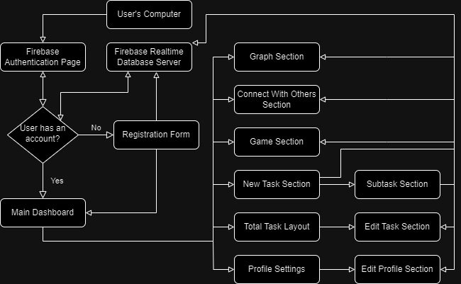

Detailing all major components and interactions of the system. We will be utilizing Firebase Authentication and Realtime Database.

## Figure 2: Component Diagram

Component Figure 2.1

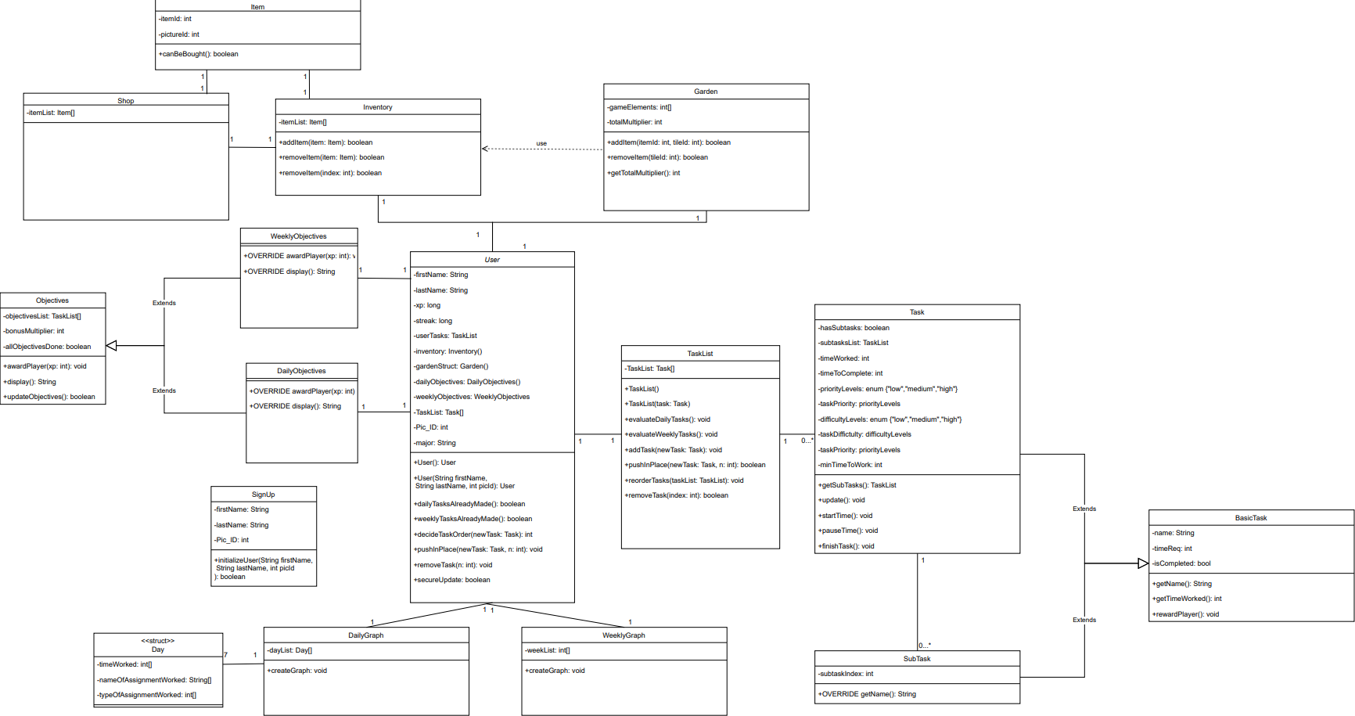

Component Figure 2.2



Component Figure 2.3



Component Figure 2.4



Component Figure 2.5



Component Figure 2.6



## Figure 3: UI Storyboard

Storyboard Figure 3.1:

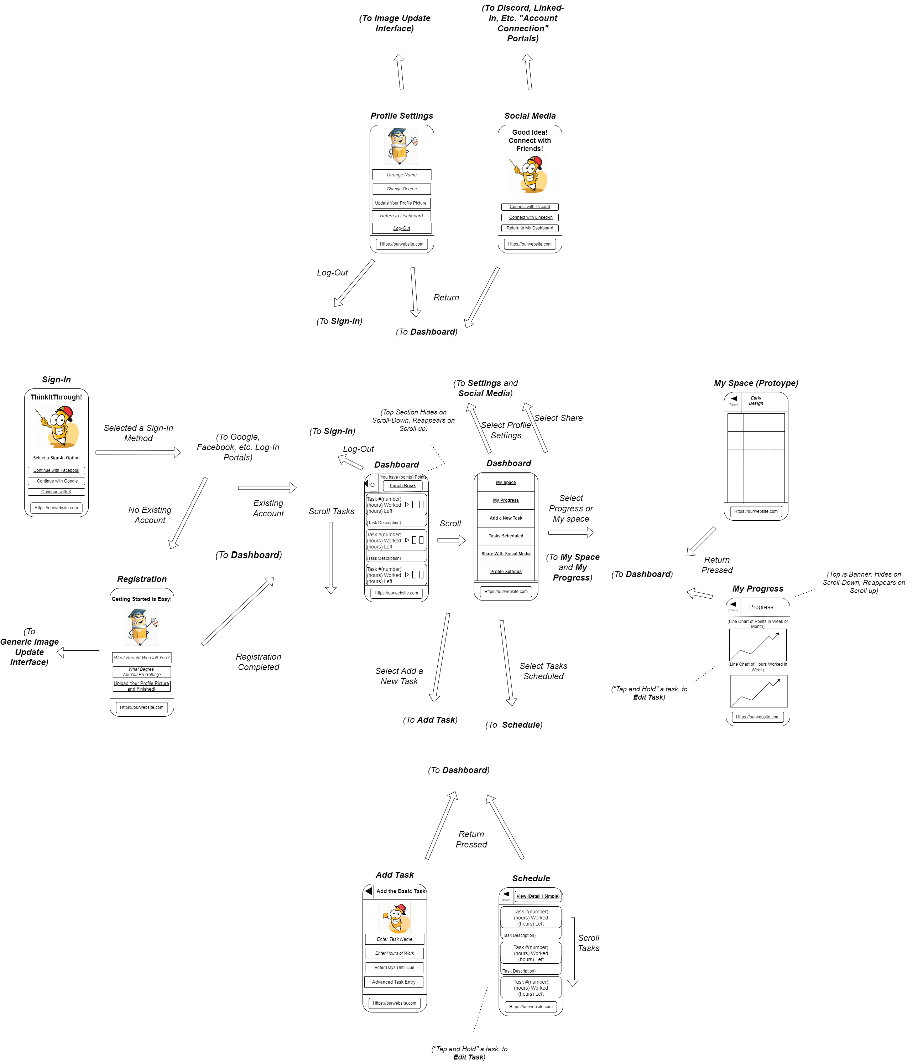

Storyboard Figure 3.2:



Storyboard Figure 3.3:



Storyboard Figure 3.4:



## Figure 4: Message Documentation

All the information that must be created when a user fills out the registration form:

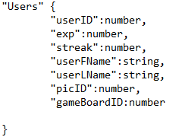 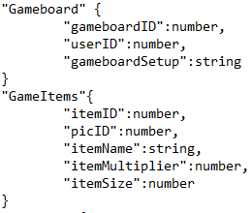

This also includes Gameboard object, which must be created when a user is created (Gameboards are unique to each user). Outside of this, the program can pull these objects individually, separately pulling the entirety of the data within each object depending on what is specified in the call function.

Here is the data that is pulled when dealing with tasks:

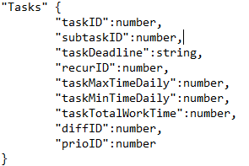 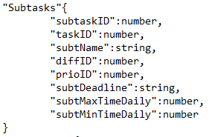

To input the data into the server, each of these must be filled in the “New Tasks” modal that appears (either for subtasks or tasks). For a subtask to be made, however, it requires an associated task with the taskID in its definition.

Here are the helpful entities we use to define certain traits in the main objects:

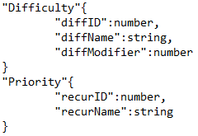 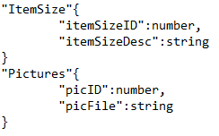 

For all of these except Pictures, we will have pre-defined certain objects to use. The Pictures entity can be modified by a user inputting a picture as a profile picture—otherwise, it will also have predefined data.

## Figure 5: Entity Relationship Diagram

